Supporting Information
for

Different Control of Tropical Cyclone Activity in the Eastern Pacific for two types of El Niño

Julien Boucharel¹*, Fei-Fei Jin^{2,3}, I.I. Lin⁴, Hsiao-Ching Huang⁴, and Matthew H. England¹

¹ ARC Centre of Excellence for Climate System Science, University of New South Wales, Sydney, New South Wales, Australia
² Department of Atmospheric Sciences, SOEST, University of Hawaii at Manoa,
Honolulu, Hawaii, USA
³ Laboratory for Climate Studies, Beijing Climate Center, Chinese Meteorological
Agency, Beijing, China
⁴ Department of Atmospheric Sciences, National Taiwan University, Taipei 10617, Taiwan

Figures S1 to S11 and Tables S1 to S5

1/ Vertical Wind Shear (VWS) calculation:

There are two different methods to perform this calculation:

1/ The “climate-oriented” calculation, where the VWS is calculated for the different atmospheric reanalysis locally at each grid point and then averaged over a large area, e.g. region TC (130-100°W; 7-17°N) when needed (i.e. for Figs 2, 3 S4), and
2/ The “quasi-local” calculation, where the velocity fields are first averaged in a given region and then the averaged u and v (scalars) are used to calculate the VWS (i.e. Figure S9).

Where the vertical wind shear is defined as:
,
with u₂₀₀ (resp. u₈₅₀) the zonal velocity component at the 200mb (resp. 850mb) atmospheric level, and v₂₀₀ (resp. v₈₅₀) the meridional velocity component at the 200mb (resp. 850mb) atmospheric level.

The second way of performing the calculation is typically used to assess VWS associated with individual hurricanes. For instance, DeMaria [1996] average the velocity fields over a circular region with a radius of 600km around the storm’s center. This method requires the u and v fields to have a high temporal resolution, usually 6-hourly; and gives insights into how the high-frequency local atmospheric conditions can affect a storm evolution (intensification or lack thereof) [DeMaria and Kaplan, 1994].

The present study focuses on both oceanic and atmospheric conditions, associated with particular climate events and how they can affect the tropical cyclone intensity over an entire basin and during an entire hurricane season. So we are not looking at individual storm events but more how climate statistics can influence a tendency towards more or less intense hurricanes. The region of interest in this regard is wide: either TC region, which roughly corresponds to the region where most storms undergo their rapid intensification; or even the entire Eastern Pacific. In any case, the size of the integration domain is such than both methods give extremely similar results, as shown by the comparison between Fig. 3f,g,h calculated following method #1 and Fig. S9f,g,h, calculated following Method #2.
Method #1 (again local VWS calculation followed by a spatial average), as presented in the main manuscript, has been extensively used in various studies that investigated the influence of modes of natural climate variability (such as ENSO, MJO, Australian monsoon…) on TC activity [Yu et al., 2010; Jiang et al., 2012; Klotzbach and Blake, 2013 among others].

2/ Additional statistical evidence:

Table S3 shows that both T55 and T80 well-pass statistical level of > 99% confidence level, when comparing the 2 groups (EP and CP flavors of El Niño). Also, ACE itself passes the 95% confidence level between EP and CP groups. However, SST and the atmospheric controls (e.g. shear, relative humidity....) all are lower than 95% confidence level (i.e. fail to pass). Also, since the number of VWS data is small with large variations, the distribution is likely to be non-Gaussian; therefore, we perform a Mann-Whitney-Wilcoxon non-normal statistical test (also called U-test). Again, the VWS fails to pass this test, although only marginally for the NCEP reanalysis (not shown). In other words, in a climate-control sense, T55 and T80 are much stronger control factors, whereas atmospheric factors appear to exert “higher-frequency” controls (e.g. cyclogenesis). For more completeness, we include in this supplementary information diagnostics (Figure S10) performed using another atmospheric product: namely, the NASA reanalysis for the satellite era using a major new version of the Goddard Earth Observing System Data Assimilation System Version 5 (GEOS-5). Again, changes in VWS distributions fail to pass the statistical tests, but this additional analysis confirms the tendency for VWS to be positive (and distinct from other classes of events, i.e. CP, Niña and neutral conditions) during the hurricane season post an EP El Niño, therefore destructive to Tropical Cyclones intensification. This confirms the control of ocean heat content, and highlights the likely detrimental influence of VWS during hurricane seasons post EP events.
We have also assessed the VWS calculations following DeMaria [1996] using ERA interim 6-hourly global reanalysis outputs for each individual hurricane occurring in the seasons listed under the CP/EP groups (cf. Table S1, and Table 1a for EP events and 1b for CP events below). The u and v wind components at each level were averaged over a circular area with a radius of 600 km centered on TC tracks. Then the VWS was averaged along the track of the storms. This approach, a pain staking exercise, shows that the difference in shear between the two groups does not pass the confidence test. It again supports that the VWS is more of a high-frequency control. For both EP and CP El Niño flavors, the “absolute shear values” are around 5-6 m/s (Table 2). Such low values of shear (typically < 10 m/s) will therefore not prohibit TC intensification [Frank and Ritchie, 2001]. In other words, the significant difference found in TC activity (i.e. ACE, cf. Fig. 3, S9 and Table S3) between the different modes of ENSO is largely explained by the difference (significant) of subsurface heat available that can promote a rapid and strong intensification of storms in the EP case but not in the CP’s.

3/ Characteristics of ocean/atmosphere reanalysis products used in this study:

Table S4 provides the spatial and temporal resolutions of the different oceanic and atmospheric datasets used in this study. Note that we intentionally disregarded the updated version of ORA-S3, i.e. ORA-S4 [Balmaseda et al., 2013], as the vertical structure (e.g., mean flow, stratification…) in this region is dubious, in particular the vertical velocities in this region of strong upwelling [Balmaseda, personal communication].

4/ Adapted Saffir-Simpson scale used in this study:

Table S5 describes the lower limit thresholds used to delineate the hurricane strength (i.e. category).

5/ Choice of TC region:

Figure S10 shows the location where the strongest wind speed intensification occurs for every storm during the period 1959-2014. 67% (71%) of the storms (the intense storms, i.e. Category 3 and above) undergo their strongest intensification in the updated (from JBL) region TC.
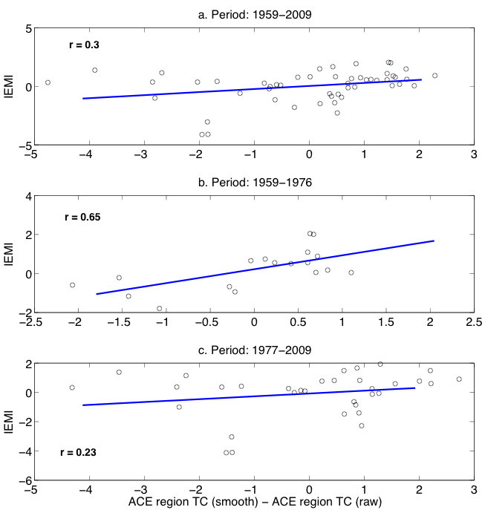

Figure S1. Correlations between the “Improved El Niño Modoki Index” as defined by Li et al. [2010] and the residual between the raw and smoothed (3-years moving average as in JBL) time series of ACE anomalies summer average in region TC for 3 different periods: (a) 1959-2009; (b) 1959-1976 and (c) 1977-2009.

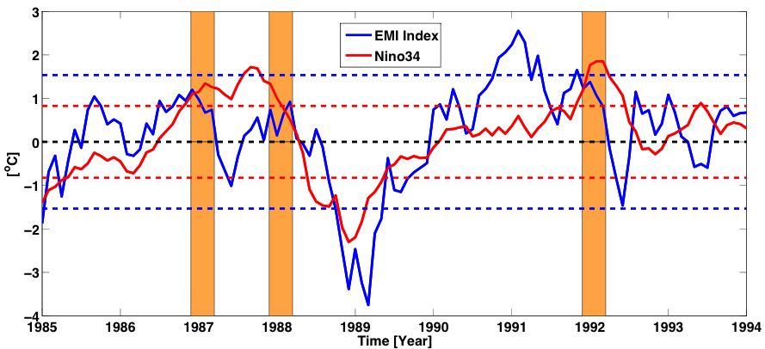
Figure S2. The Improved El Niño Modoki index (EMI) [Li et al., 2010] (solid red line) and Niño3.4 time series (solid blue line), their respective plus and minus one standard deviations represented by the dotted lines. El Niños events of 1986-87; 1987-88 and 1991-92 are highlighted in orange.

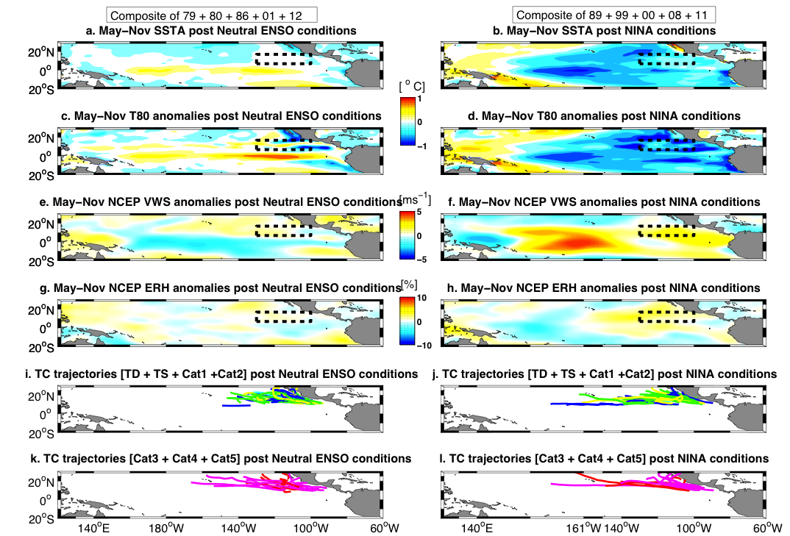
Figure S3. As per Fig. 1 (main manuscript) only showing composite of hurricane seasons (May-November) monthly anomalies following post Neutral and Niña (respectively) conditions of SST (a., respectively b.), subsurface temperature averaged in the first 80m (c., respectively d.), vertical wind shear (VWS, e. respectively f.) and environmental relative humidity (ERH, g. respectively h.) from NCEP product. Panel i. (respectively j.) shows the minor Tropical Cyclones trajectories (Tropical depressions to Category 2 hurricanes). Panel k. (respectively l.) shows the same for major Tropical Cyclones (Category 3 and above). Years used to composite the neutral and Niña events are indicated at the top of the figure. Tropical Depressions are in dark blue, Tropical storms in cyan, Category 1 in green, Category 2 in yellow, Category 3 in red, Category 4 in magenta and Category 5 in black. Region TC (130-100°W; 7-17°N) is represented by the thick dashed black box in panels a to h.

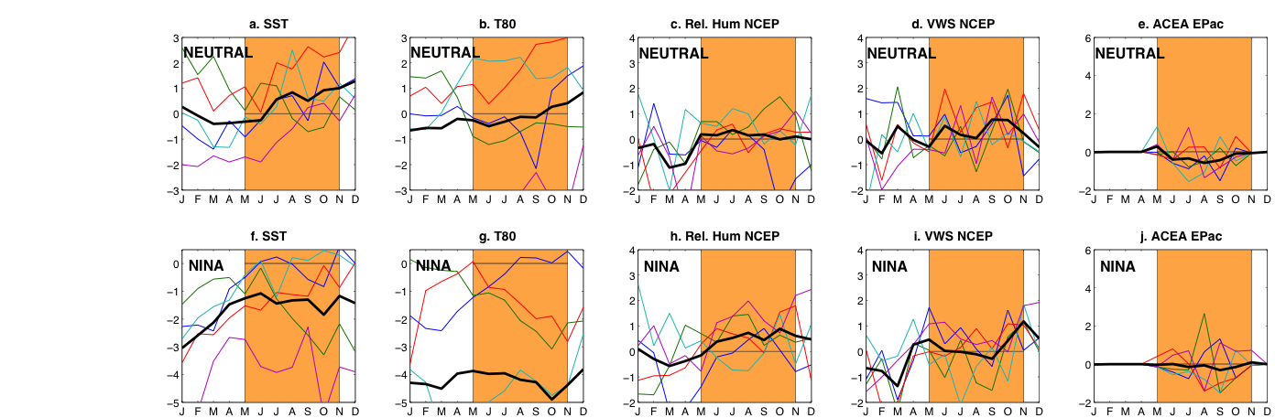

Figure S4. As per Fig. 2 (main manuscript) only showing evolution of SST anomalies (a. and f.), subsurface temperature anomalies averaged in the first 80m (b. and g.), environmental relative humidity (ERH, c. and h.), vertical wind shear anomalies for NCEP products (VWS, d. and i.), and ACE anomalies (e. anfd j.) leading up and during Eastern Pacific hurricane season (shaded in orange) post neutral (top panels) and Niña years (bottom panels. see Fig. S3 and Table S2). Anomalies are averaged in region TC (130-100°W; 7-17°N). Thin colored lines represent variables for different neutral El Niño events used to average the “composite” variable (thick black line). Note that all time series have been normalized by their standard deviation.

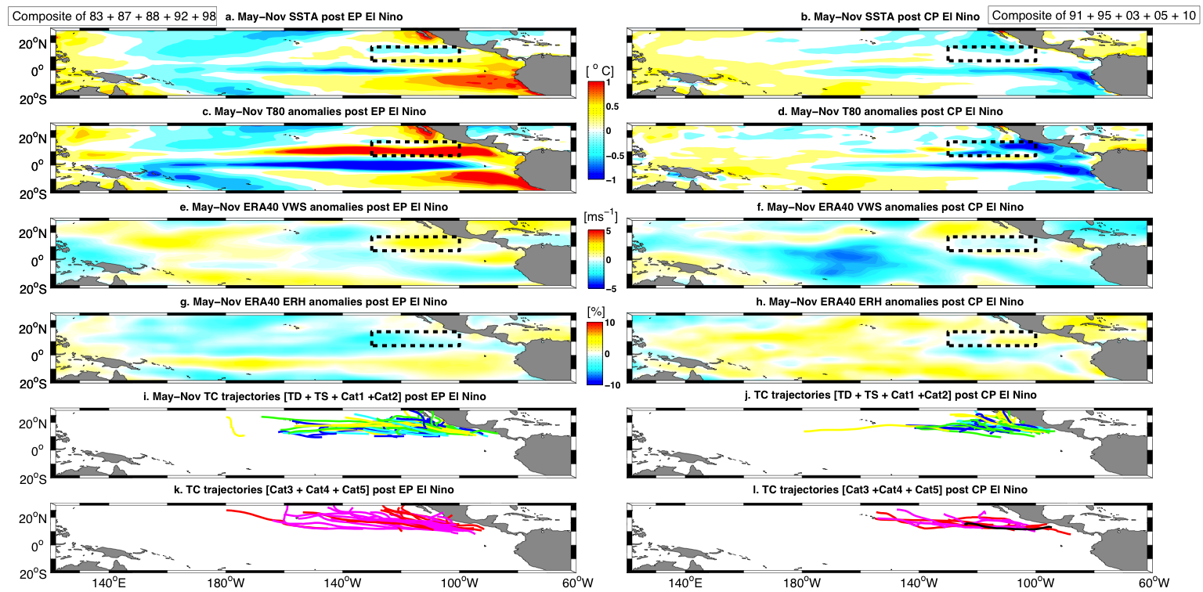
Figure S5. As per Figure 1 for ERA40 reanalysis product.

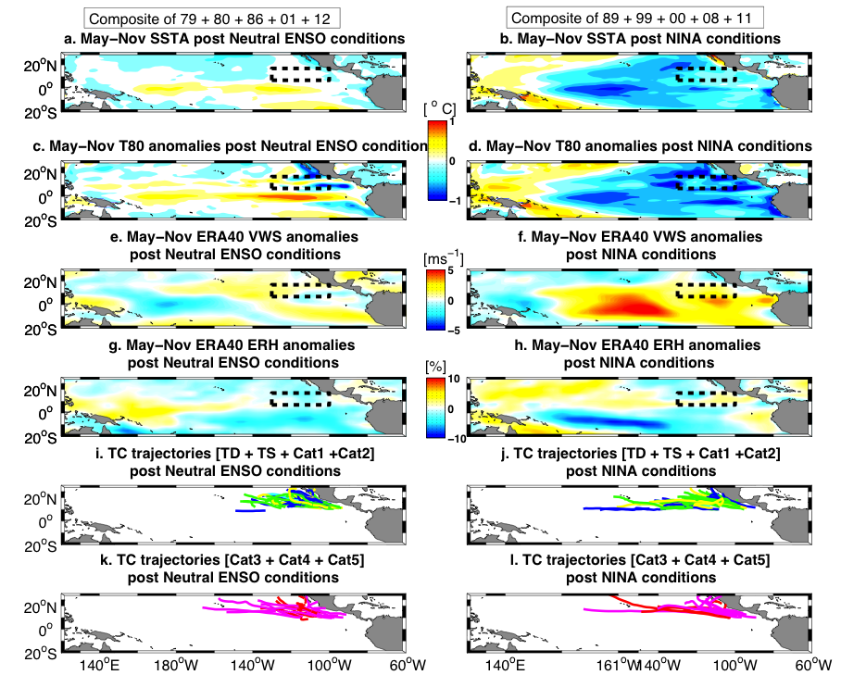
Figure S6. As per Figure S3 for ERA40 reanalysis product.

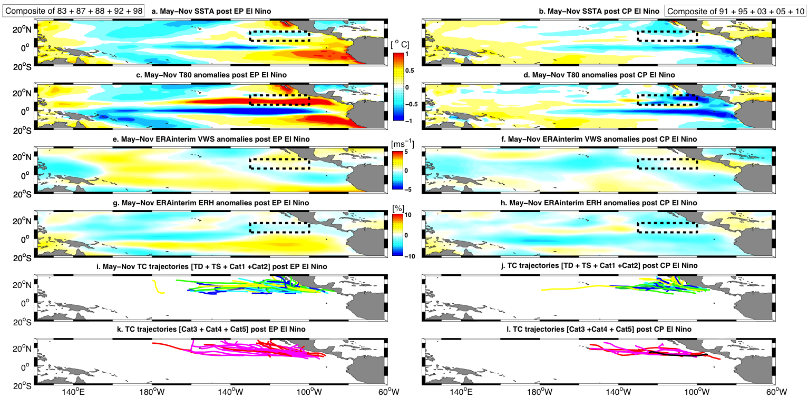

Figure S7. As per Figure 1 for ERA interim reanalysis product.

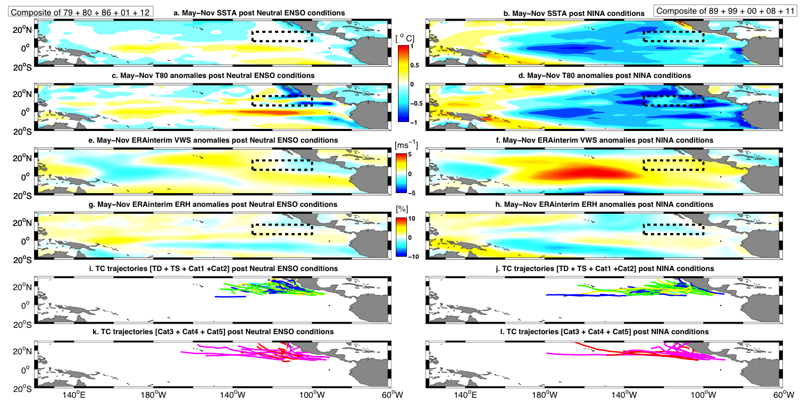
Figure S8. As per Figure S3 for ERA interim reanalysis product.

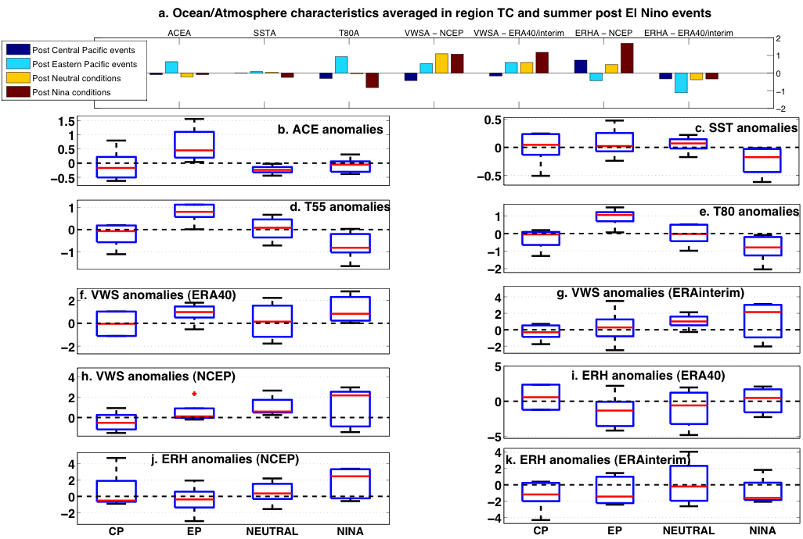
Figure S9. As per Figure 3 with a different method of VWS calculation. Refer to the method section below for more details.

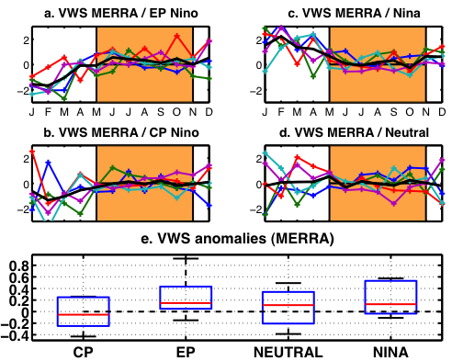

Figure S10. Evolution of standardized vertical wind shear (VWS) anomalies from MERRA product leading up to and during the Eastern Pacific hurricane season (MJJASON, shaded in orange) following Eastern Pacific (EP) El Niño events (a.), Central Pacific (CP) El Niño events (b.), Niña (c.) and Neutral (d.) events. The distributions of VWS are displayed in (e.). The boxes show the 25th-75th percentile range, the whiskers the inter-events range, and the median is marked in red.

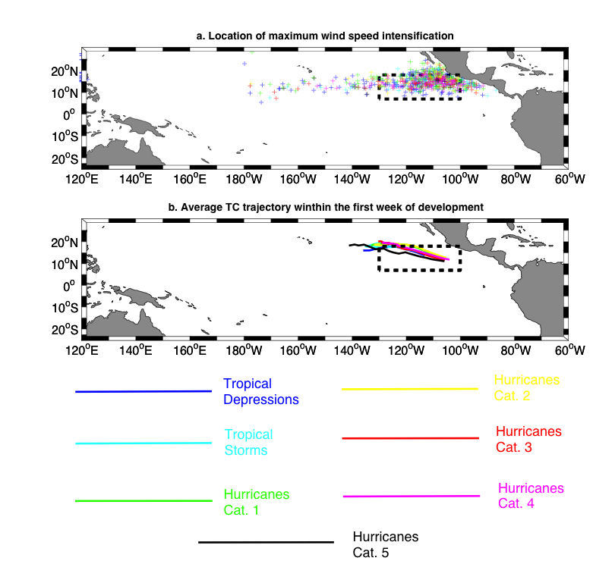
Figure S11. (a.) Location of maximum wind speed intensification for every storm that occurred between 1959 and 2014. (b.) Average trajectories during the first week of hurricanes depending on their category (based on the Saffir-Simpson scale, see Table S4). Dashed black box delineates region TC.

Post CP El Niño
TC category  Events | TD | TS | Cat1 |  | Cat2 | Cat3 | Cat4 | Cat5
1990-91 | 0 | 2 | 4 |  | 0 | 3 | 2 | 0
1994-95 | 0 | 3 | 3 |  | 1 | 0 | 3 | 0
2002-03 | 5 | 2 | 3 |  | 4 | 0 | 0 | 0
2004-05 | 6 | 0 | 3 |  | 2 | 1 | 1 | 0
2009-10 | 1 | 1 | 1 |  | 0 | 1 | 0 | 1
Total (moderate/intense storms) | 41(-15%) |  |  |  |  | 12 (-14%)
Total | 53(-15%)
Post EP El Niño
1982-83 | 5 | 1 |  | 3 | 1 | 3 | 5 | 0
1986-87 | 7 | 3 |  | 3 | 3 | 2 | 2 | 0
1987-88 | 4 | 1 |  | 5 | 2 | 1 | 2 | 0
1991-92 | 6 | 3 |  | 4 | 2 | 2 | 6 | 0
1997-98 | 3 | 1 |  | 3 | 0 | 3 | 3 | 0
Total (moderate/intense storms) | 60 (+25%) |  |  |  |  | 29 (+107%)
Total | 89 (+44%)
Post Neutral ENSO years
1978-79 | 2 | 0 |  | 1 | 0 | 2 | 2 | 0
1979-80 | 7 | 0 |  | 2 | 2 | 2 | 1 | 0
1985-86 | 6 | 0 |  | 5 | 1 | 0 | 3 | 0
2000-01 | 5 | 1 |  | 4 | 2 | 0 | 1 | 0
2011-12 | 6 | 0 |  | 3 | 1 | 2 | 1 | 0
Total (moderate/intense storms) | 48 |  |  |  |  | 14
Total | 62
Post La Niña
1988-89 | 5 | 2 |  | 5 | 0 | 2 | 2 | 0
1998-99 | 2 | 1 |  | 2 | 2 | 1 | 1 | 0
1999-00 | 8 | 2 |  | 4 | 1 | 1 | 1 | 0
2007-08 | 8 | 0 |  | 4 | 1 | 1 | 1 | 0
2010-11 | 0 | 0 |  | 4 | 1 | 1 | 4 | 0
Total (moderate/intense storms) | 52(+8%) |  |  |  |  | 15(+7%)
Total | 67(+8%)
Table S1. Number of Tropical Cyclones according to their category (based on a slightly modified Saffir-Simpson scale, Table S5 for a description) that occurred during the hurricane season (May-November) following Central Pacific (CP), Eastern Pacific (EP) El Niño, Neutral and La Niña events. EP events: 1982/83, 1986/87, 1987/88, 1991/92 and 1997/98. CP events: 1990/91, 1994/95, 2002/03, 2004/05, 2009/10. Neutral events: 1978/79, 1979/80, 1985/86, 2000/01, and 2011/12. La Niña events: 1988/89, 1998/99, 1999/00, 2007/08, 2010/11. The previous year is also used to name the events as both Niña and Niño peak between November (year-1) and February, but the statistics are performed over the boreal summer of the bolded year in the first column (i.e. the hurricane season after the events peak). Bold percentages between brackets represent the increase/decrease in TC number from post-neutral years to post-Niña/Niño conditions.

Table S2a.  TD,TS,C1-C5 T-test | Mean  C3-C5/TD,TS,C1-C5 points  (%) | Variance C3-C5/TD,TS,C1-C5 points | Sample number  TD,TS,C1-C5 | T value | Confidence Level  (one-tail)
EP El Niño  (83, 87, 88, 92, 98) | 12.97 | 151.86 | 25 | 1.566 | 93.50-94.00%
CP El Niño  (91, 95, 03, 05, 10) | 7.50 | 141.04 | 23

Table S2b.  TD,TS,C1-C5 T-test | Mean  C3-C5/TD,TS,C1-C5 points  (%) | Variance C3-C5/TD,TS,C1-C5 points | Sample number  TD,TS,C1-C5 | T value | Confidence Level  (one-tail)
EP El Niño  (83, 87, 88, 92, 98) | 12.97 | 151.86 | 25 | 1.414 | 91.50-92.00%
Neutral conditions  (79, 80, 86, 01, 12) | 7.40 | 235.79 | 25

Table S2c.  TD,TS,C1-C5 T-test | Mean  C3-C5/TD,TS,C1-C5 points  (%) | Variance C3-C5/TD,TS,C1-C5 points | Sample number  TD,TS,C1-C5 | T value | Confidence Level  (one-tail)
CP El Niño  (91, 95, 03, 05, 10) | 7.50 | 141.04 | 23 | 0.025 | 50.00-52.50%
Neutral conditions  (79, 80, 86, 01, 12) | 7.40 | 235.79 | 25
Table S2. (a.) Student t-test values for the percentage difference of grid-by-grid intense TC (Category 3 and above) over all TC between Eastern Pacific (EP) and Central Pacific (CP) El Niño events. (b.) Same between EP events and neutral conditions. (c.) Same between CP events and neutral conditions.

 | Mean EP | Var EP | Number_EP | Var/N_EP | Mean CP | Var CP | Number_CP | Var/N_CP | |MeanEP-MeanCP| | d.f | T | Confidence Level(one-tail) (%)
ACE | 0.6494 | 0.3740 | 5 | 0.0748 | -0.0872 | 0.3094 | 5 | 0.0619 | 0.7366 | 7.9293 | 1.9924 | 95.50-96.00
SST | 0.0859 | 0.0710 | 5 | 0.0142 | 0.0015 | 0.0941 | 5 | 0.0188 | 0.0844 | 7.8462 | 0.4644 | 65.00-67.50
T55 | 0.7654 | 0.2064 | 5 | 0.0413 | -0.2389 | 0.2949 | 5 | 0.0590 | 1.0044 | 7.7583 | 3.1721 | 99.00-99.50
T80 | 0.9316 | 0.2801 | 5 | 0.0560 | -0.3033 | 0.3525 | 5 | 0.0705 | 1.2348 | 7.8967 | 3.4715 | 99.50-99.75
VWS NCEP | 0.5374 | 1.0545 | 5 | 0.2109 | -0.4253 | 0.9056 | 5 | 0.1811 | 0.9626 | 7.9541 | 1.5375 | 91.50-92.00
VWS ERA40 | 0.8898 | 0.7672 | 5 | 0.1534 | -0.0446 | 2.2721 | 2 | 1.1360 | 0.9344 | 1.2825 | 0.8228 | 70.00-72.50
VWS ERAinterim | 0.2124 | 4.7014 | 5 | 0.9403 | -0.1168 | 1.0714 | 5 | 0.2143 | 0.3291 | 5.7331 | 0.3063 | 60.00-62.50
RHUM NCEP | -0.4338 | 3.2270 | 5 | 0.6454 | 0.7349 | 5.4748 | 5 | 1.0950 | 1.1687 | 7.4996 | 0.8859 | 77.50-80.00
RHUM ERA40 | -1.4903 | 6.1283 | 5 | 1.2257 | 0.5731 | 6.3778 | 2 | 3.1889 | 2.0634 | 1.8482 | 0.9821 | 77.50-80.00
RHUM ERAinterim | -0.7481 | 3.1529 | 5 | 0.6306 | -1.2293 | 3.5140 | 5 | 0.7028 | 0.4813 | 7.9766 | 0.4168 | 65.00-67.50
Table S3. The last two columns show the Student t-test and the one tailed confidence level values for the difference between EP and CP flavors in the variables used in Fig. 3. The first 4 columns (in red) show respectively the mean, variance, number of events and ratio of variance by number of events for the EP flavor. The following 4 columns (in blue) show the same for the CP flavor.

Reanalysis product | Longitude resolution | Latitude resolution | Time resolution | Period
ORA-S3 | 1° | 0.5° | Monthly outputs | 1959-2009
GODAS | 1° | 1/3° | Monthly outputs | 1980-2014
NCEP-NCAR | 2.5° | 2.5° | Monthly average of daily outputs | 1949-2014
ERA40 | 2.5° | 2.5° | Monthly average of daily outputs | 1959-2001
ERA interim | 3/4° | 3/4° | Monthly average of daily outputs | 1979-2012
MERRA | 1.25° | 1.25° | Monthly outputs | 1979-2014
Table S4. Spatial and temporal resolution of the reanalysis products used in this study.

Storms Category | Threshold (m/s) | Threshold (Knots)
TD | 17.5 | 34
TS | 27.2 | 52.9
Category 1 | 30.8 | 59.9
Category 2 | 42.5 | 82.6
Category 3 | 49.2 | 95.6
Category 4 | 57.8 | 112.4
Category 5 | 69.7 | 135.5
Table S5. “Modified” Saffir-Simpson lower limit scale used in this study to delineate storms categories.

Additional references (not already present in the main manuscript):

Balmaseda, M. A., Mogensen, K. and Weaver, A. T., Evaluation of the ECMWF ocean reanalysis system ORAS4. Q.J.R. Meteorol. Soc., 139, 1132–1161. doi: 10.1002/qj.2063, (2013).

DeMaria, M. and J. Kaplan, A statistical hurricane intensity prediction scheme (SHIPS) for the Atlantic basin. Wea. Forecasting, 9, 209-220, (1994).

Frank, W.M and E.A. Ritchie, Effects of Vertical Wind Shear on the Intensity and Structure of Numerically Simulated Hurricanes. Mon. Wea. Rev., 129, 2249–2269 (2001).

Jiang X., M. Zhao, and D.E. Waliser, Modulation of tropical cyclones over the eastern Pacific by the intraseasonal variability simulated in an AGCM. J. Climate, 25, 6524–6538, (2012).

Klotzbach, P.J and E.S. Blake, North-Central Pacific Tropical Cyclones: Impacts of El Niño–Southern Oscillation and the Madden–Julian Oscillation. J. Climate, 26, 7720–7733, (2013).

Yu, J.-H., Y. Wang, and K. Hamilton, Response of tropical cyclone potential intensity to a global warming scenario in the IPCC AR4 CGCMs. J. Climate, 23, 135 4-1373, (2010).

* Corresponding author address: ARC Centre of Excellence for Climate System Science, University of New South Wales, Sydney, NSW 2052, Australia. E-mail: j.boucharel@unsw.edu.au

